19CSE301 Computer Networks Labsheet8

Address Resolution Protocol

ARP is covered in the text. RFC 826 (ftp://ftp.rfc-editor.org/innotes/std/std37.txt) contains the gory details of the ARP protocol, which is used by an IP device to determine the IP address of a remote interface whose Ethernet address is known.

**Part 1: Analyzing the ARP within the same subnet**

**Step 1:** **Using the ARP command**

Open a command/DOS window (get to the DOS prompt).

Outcome: Record your:

• IP address, Subnet mask, Default gateway

Type the command: C:\> arp

View all of the options.

Type the command: C:\> arp -a

Chance are that your computer might already have entries in its ARP table. to clear the table type: C:\> arp –d *

Or using C:\> arp –d

**Step 2: ARP for a local host**

Use Wireshark to capture the following ARP and ICMP (ping) traffic.

Ping: Use the ping command to ping one of the other computers on the same network as your computer (and that is not currently in your ARP table). To be sure that your ARP table is empty, clear the ARP before doing the ping.

Example:

C:\> arp –d *

C:\> arp -a

C:\> ping 192.168.251.6

ARP: View the ARP table again.

C:\> arp –a

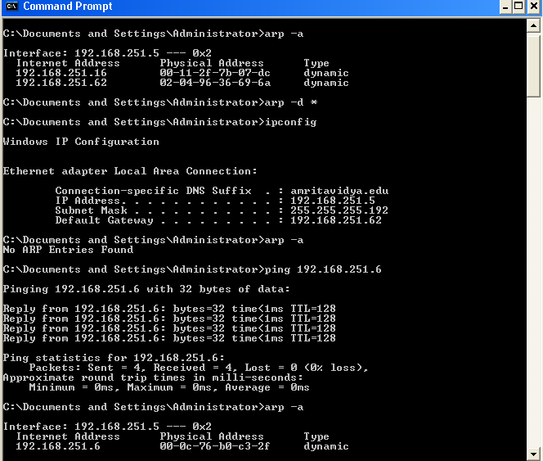

Submit the following screenshots with identity:

1. New entry added in the arp table after ping to local host having IP address say a.b.c.d. Show the command prompt outputs of arp table before and after the ping command.

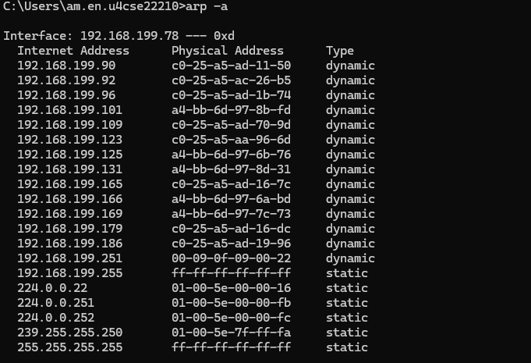

Ping 192.168.199.169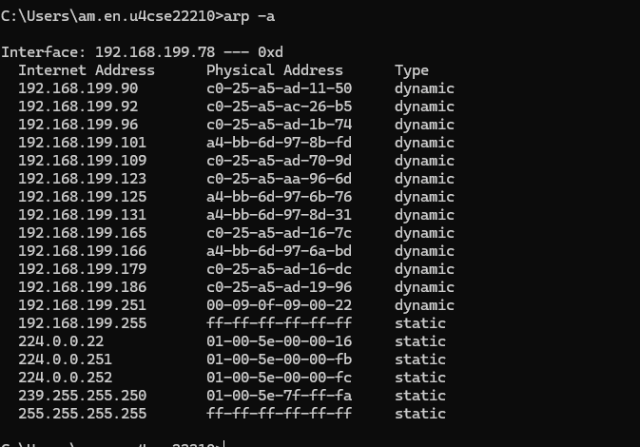

1. Show the ARP query frame for resolving the MAC address of a.b.c.d in the Wireshark.

Ping 192.168.199.175

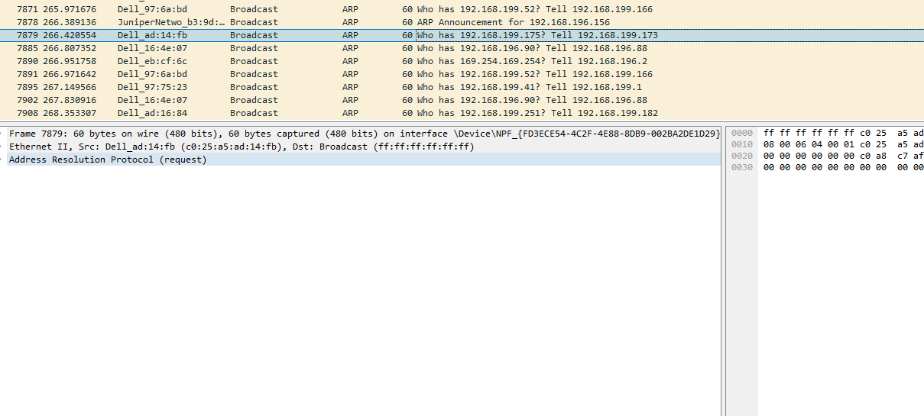

1. Show the corresponding ARP reply frame in the Wireshark

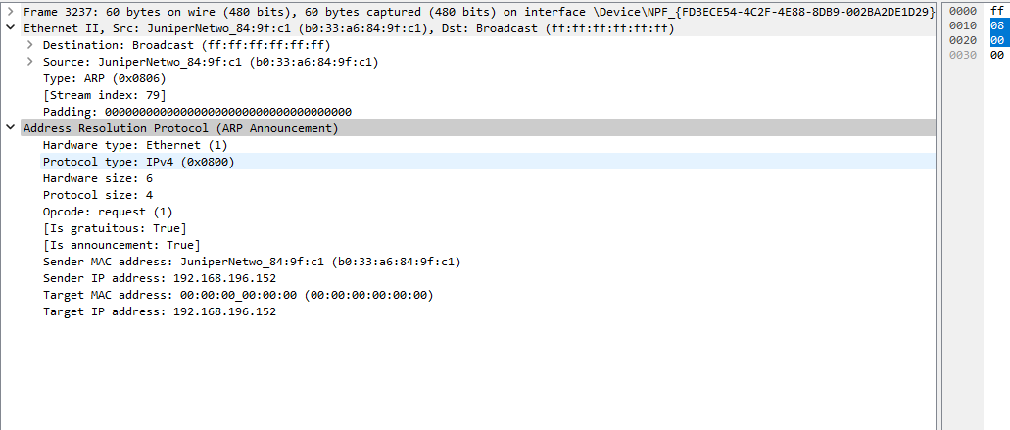

**Step3: Analyse ARP within the same subnets in the simulator after creating your own LAN.**

Your company is asking you to create 2 subnets Subnet A and Subnet B from the IP address space 192.168.8.0/22. The gateway router interfaces need to be assigned with the last usable host address. Ensure that proper configuration is done, so that all hosts can ping each other. Please note that PC0 and PC1 is in Subnet A. Router0 separates Subnet A and Subnet B. PC2 and PC3 in Subnet B

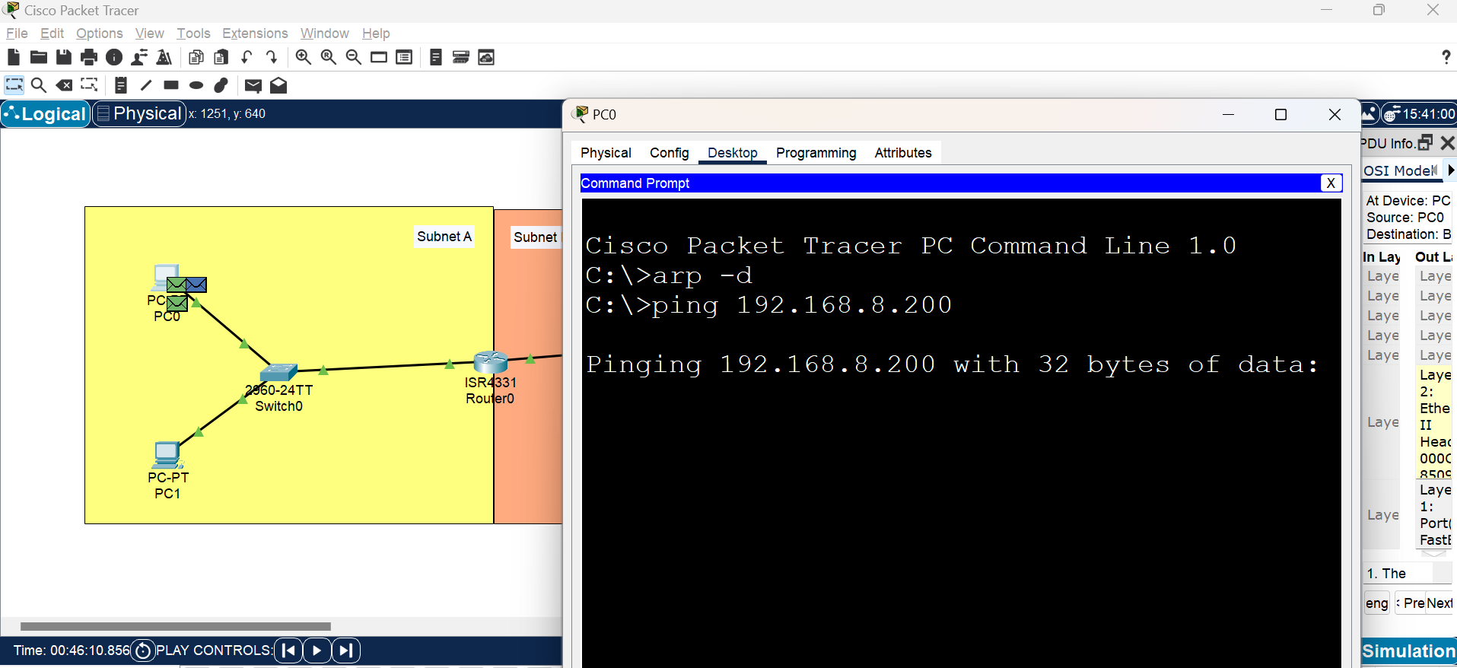

Then analyse the ARP process by doing the following.

1. Find the arp table entries of a PC say PC0 in the Subnet A. Ensure it to be empty [using arp –d]

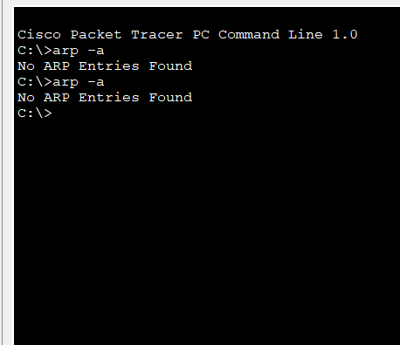

1. Ping from PC0 to PC1 in the same subnet A and use simulation to find the status of ARP frame used in the ARP process. (Note: green one is the ARP frame in the given screenshot. Provide the details after careful observation.)

ARP Broadcast frame from 192.168.8.100

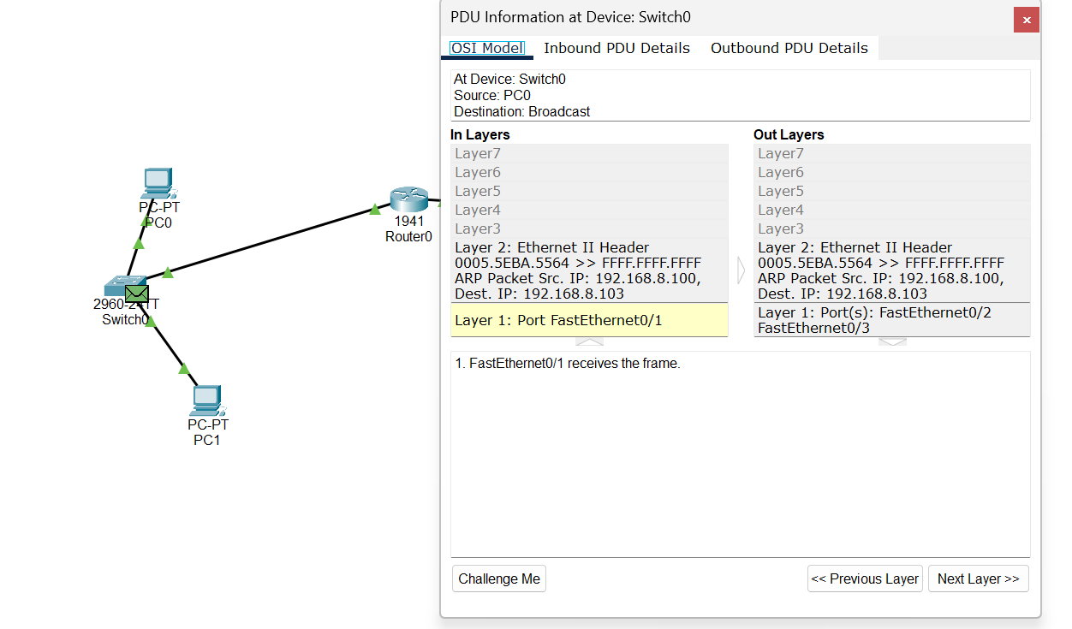

ARP Reply frame from 192.168.8.103

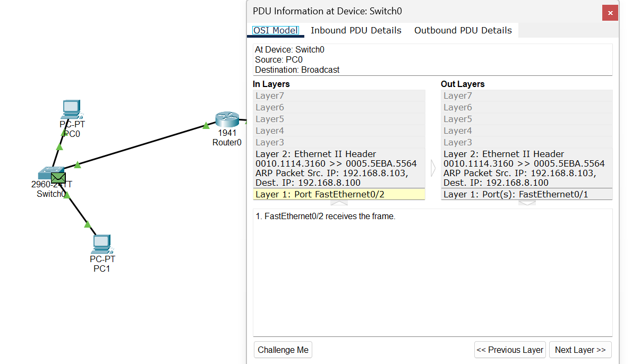

1. Find the source and destination MAC address from PC0 to PC1

Destination:0010.1114.3160

Source: 0005:5EBA:5564

**Step 4: Going outside the network: ARP Query for the default gateway**

Use Ethereal to capture the following ARP and ICMP (ping) traffic.

Ping: Use the ping command to ping a device on a different network than your computer. You can use a URL instead of an actual IP address, such as ping www.google.com. To be sure that your ARP table is empty, clear the ARP before doing the ping.

Example:

C:\> arp –d *

C:\> arp -a

C:\> ping www.google.com

ARP: View the ARP table again.

C:\> arp -a

You should now notice an entry for the default gateway in your ARP table.

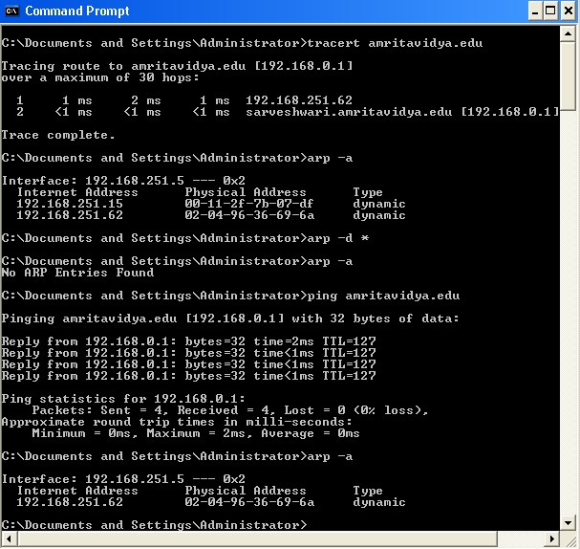

**Step5: Analyzing the ARP for the communication with different subnets**

Use your created network in the simulator. You can inspect the green frames that uses ARP protocol to do the following.

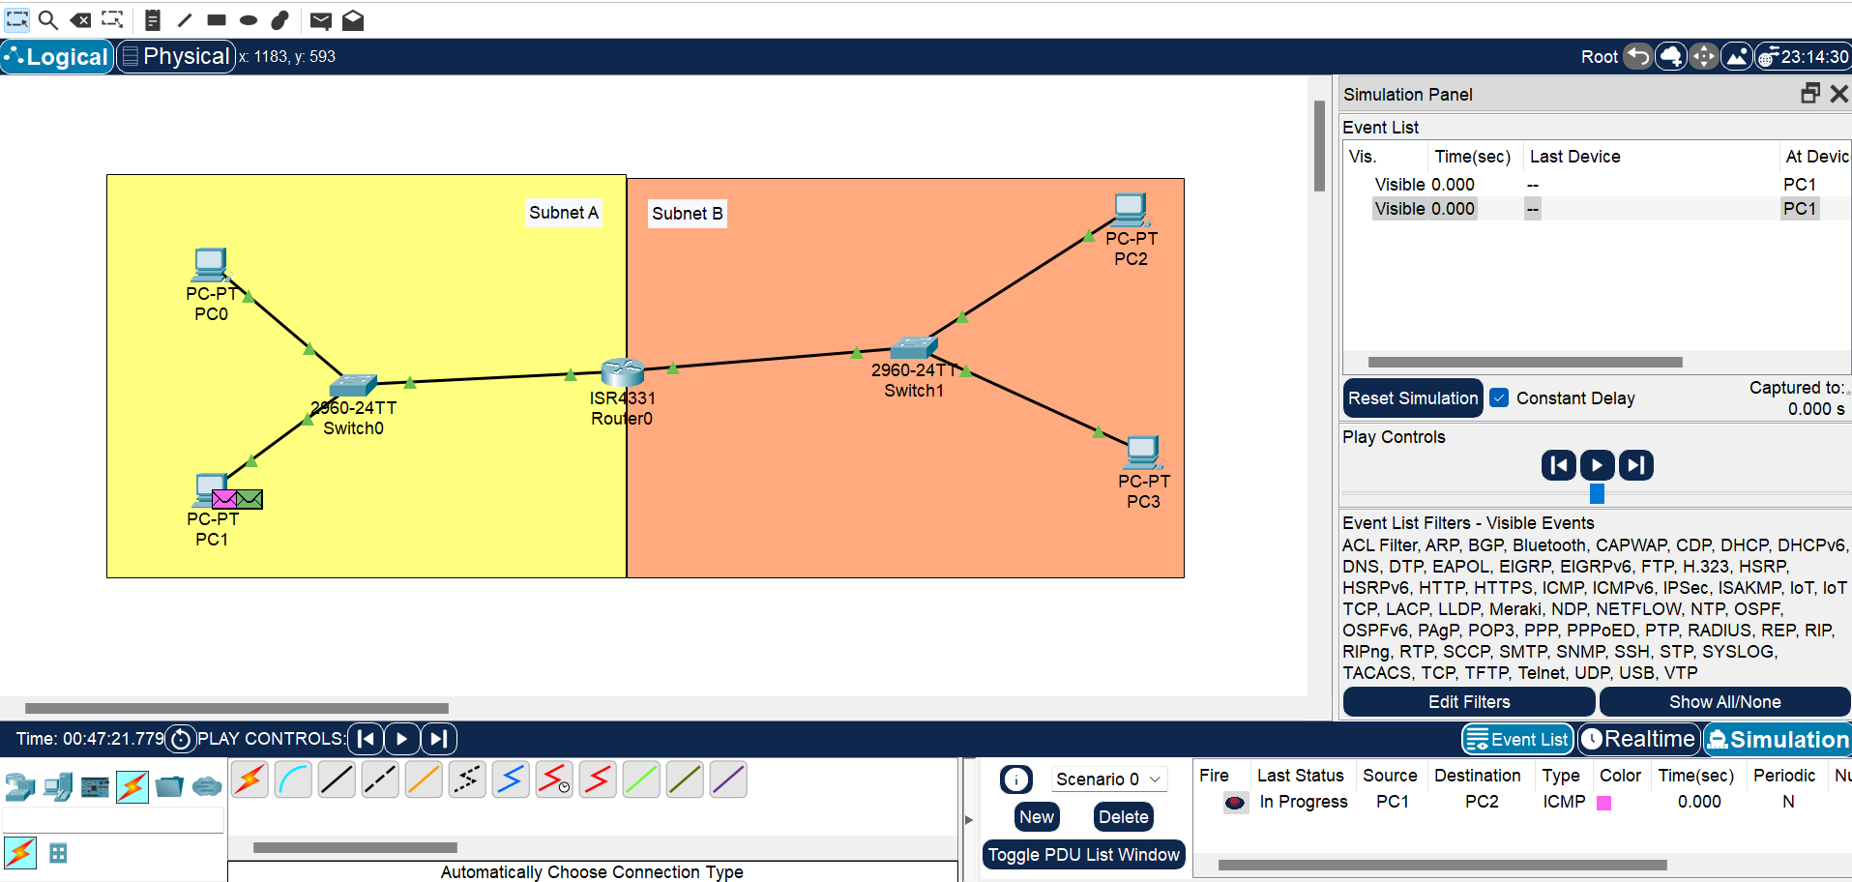

1. Find the arp table entries of PC1 in Subnet A. Ensure it to be empty [using arp –d *]

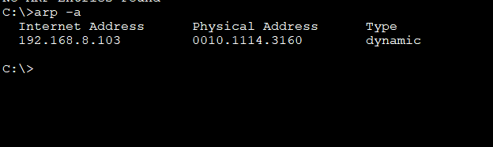

1. Ping from PC1 to PC2 in Subnet B and use simulation
2. Find the status of ARP frame used in the ARP process inside the PC1 network.

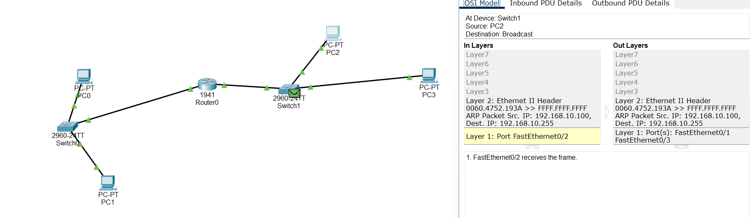

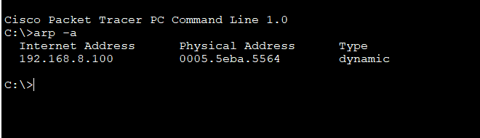

ARP Broadcast frame from 192.168.10.100

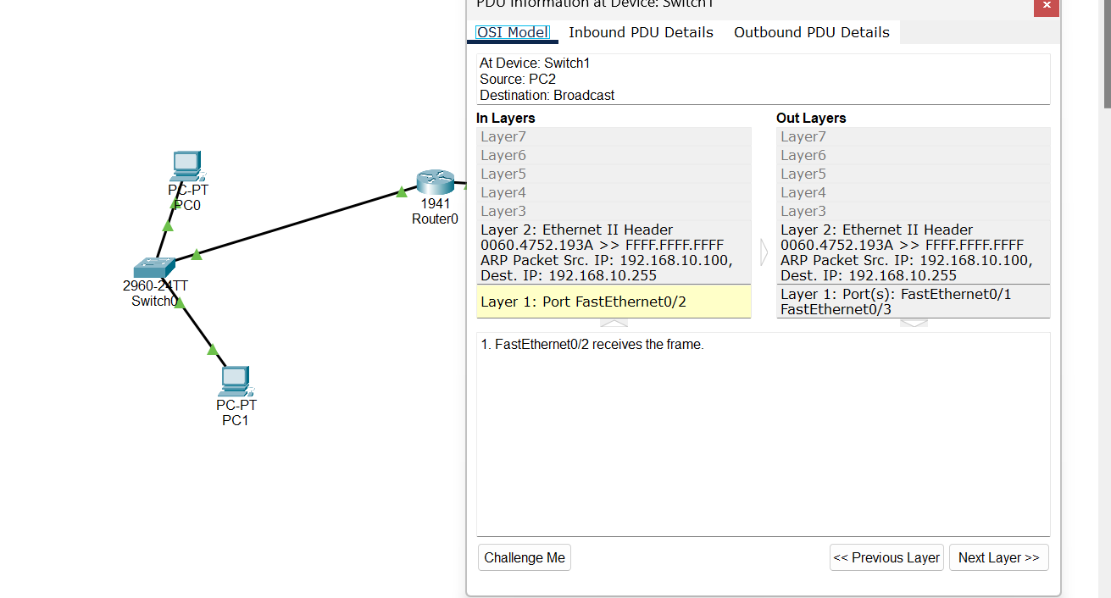

ARP Reply frame from 192.168.10.100

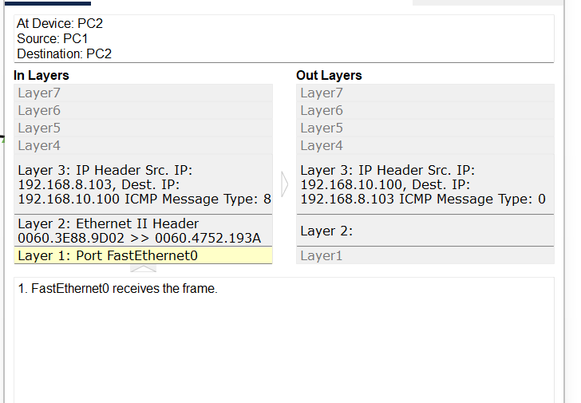

1. Find the status of ARP frame used in the ARP process outside the PC1 network.

ARP Broadcast frame from 192.168.8.100

ARP Reply frame from 192.168.10.100

1. Find the source and destination IP, MAC address from PC1 to Router0

PC1- 192.168.8.100 Router:192.168.9.254F

Find the source and destination IP, MAC address from Router0 to PC2

PC2:192.168.10.100

1. Successful ping screenshot results with proper identity like this:

